Softlayer VM - available

Vpn connection- working

Ubuntu 16.06.01 OS - available

Refer - https://github.com/hyperledger/fabric/blob/master/docs/dev-setup/devenv.md

# Pre requisites

## Install git

Refer- <https://www.digitalocean.com/community/tutorials/how-to-install-git-on-ubuntu-16-04>

sudo su

sudo apt-get update

sudo apt-get install git

## Install go

Refer- [http://tecadmin.net/install-go-on-ubuntu/#](http://tecadmin.net/install-go-on-ubuntu/)

Step 1 — Install Go Language

$ sudo apt-get update

$ sudo apt-get -y upgrade

$ wget <https://storage.googleapis.com/golang/go1.7.4.linux-amd64.tar.gz>

$ sudo tar -xvf go1.7.4.linux-amd64.tar.gz

$ sudo mv go /usr/local

Step 2 — Setup Go Environment

$ export GOROOT=/usr/local/go

$ export GOPATH=$HOME/Projects/Proj1

$ export PATH=$GOPATH/bin:$GOROOT/bin:$PATH

***to set Go path permanent add above command in **~/.profile** file

Step 3 — Verify Installation

$ go version

go version go1.7.4 linux/amd64

step 4 - Verify all configured environment variables

*root@instance-1:/home/vandana1_jadhav# go env*

GOARCH="amd64"

GOBIN=""GOEXE=""

GOHOSTARCH="amd64"

GOHOSTOS="linux"

GOOS="linux"

GOPATH="/root/Projects/Proj1"

GORACE=""

GOROOT="/usr/local/go"

GOTOOLDIR="/usr/local/go/pkg/tool/linux_amd64"CC="gcc"

GOGCCFLAGS="-fPIC -m64 -pthread -fmessage-length=0"CXX="g++"CGO_ENABLED="1"

## Install Docker

**Note:** Docker requires a 64-bit version of Ubuntu as well as a kernel version equal to or greater than 3.10. The default 64-bit Ubuntu 16.04 Droplet meets these requirements.

Refer:

<http://www.techrepublic.com/article/how-to-install-docker-on-ubuntu-16-04/>

https://www.digitalocean.com/community/tutorials/how-to-install-and-use-docker-on-ubuntu-16-04

Step -1 Update apt and add the key and repo

$ sudo apt-get update

$ sudo apt-key adv --keyserver hkp://p80.pool.sks-keyservers.net:80 --recv-keys 58118E89F3A912897C070ADBF76221572C52609D

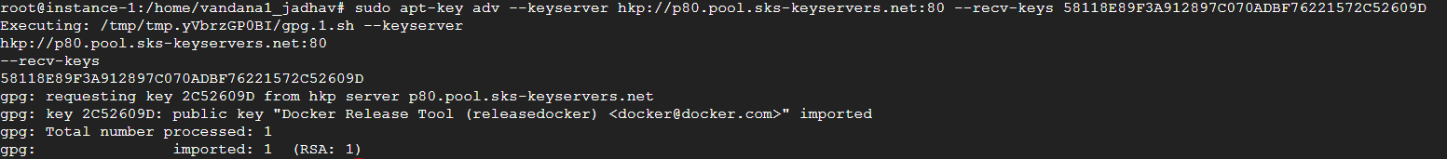

Step -2 Install the dependencies

sudo apt-get install linux-image-extra-$(uname -r) linux-image-extra-virtual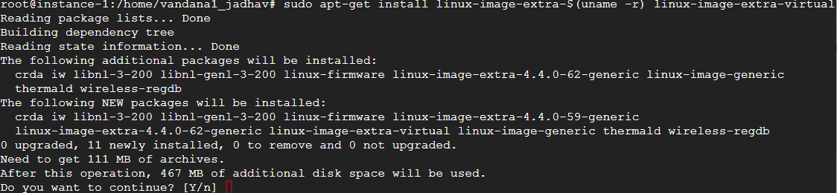Enter – Y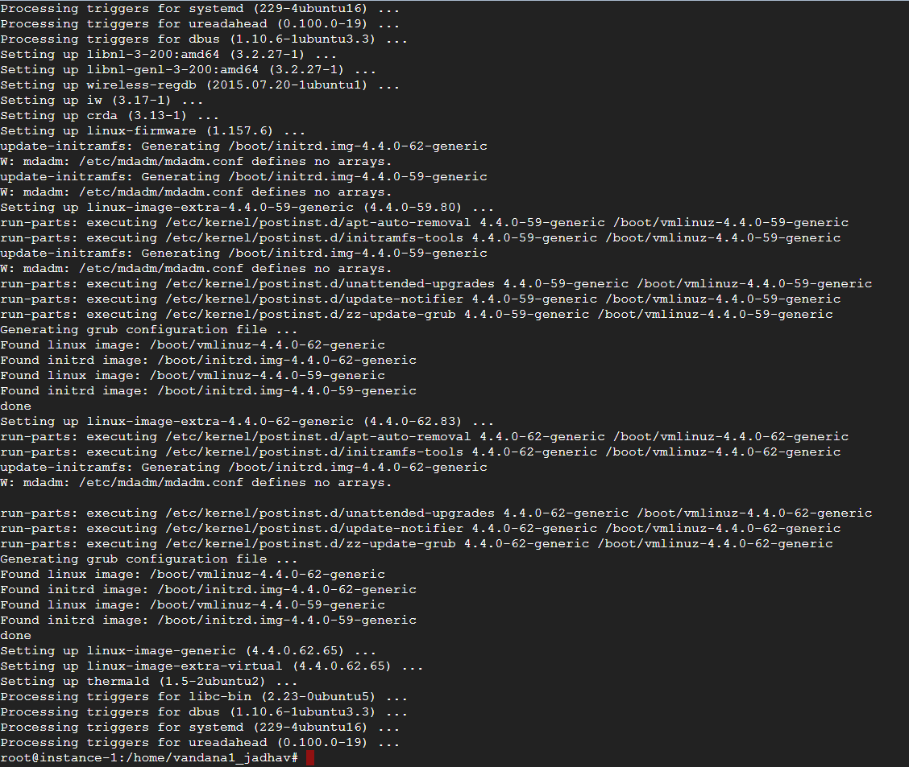

Step -3 Install Docker

$ sudo apt-add-repository 'deb https://apt.dockerproject.org/repo ubuntu-xenial main'

$ sudo apt-get update

$ apt-cache policy docker-engine

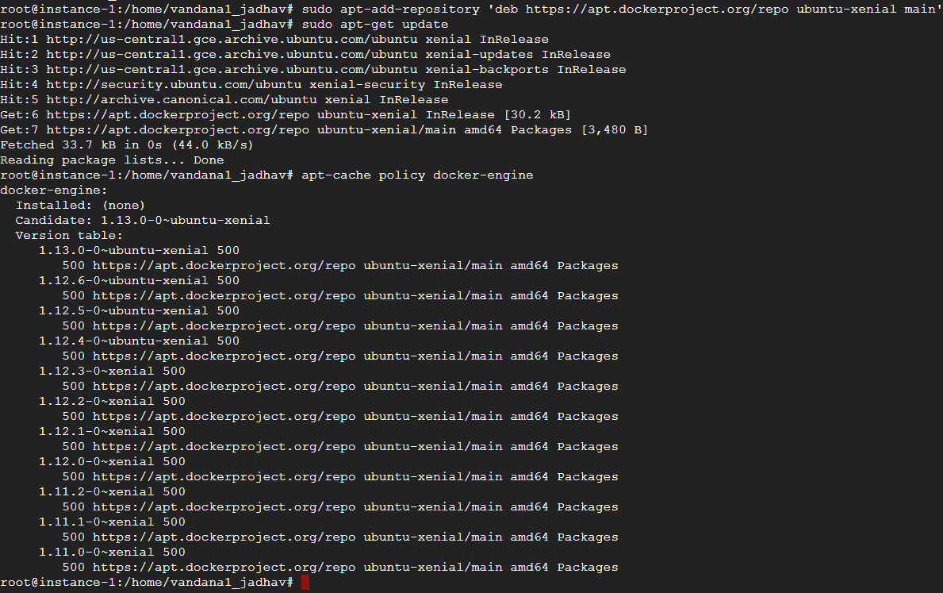

Not needed: $ sudo apt-get install docker-engine=1.8.3-0~trusty

$ sudo apt-get install docker-engine=1.12.6-0~trusty

Not needed if above worked

*$ sudo apt-get install -y docker-engine*

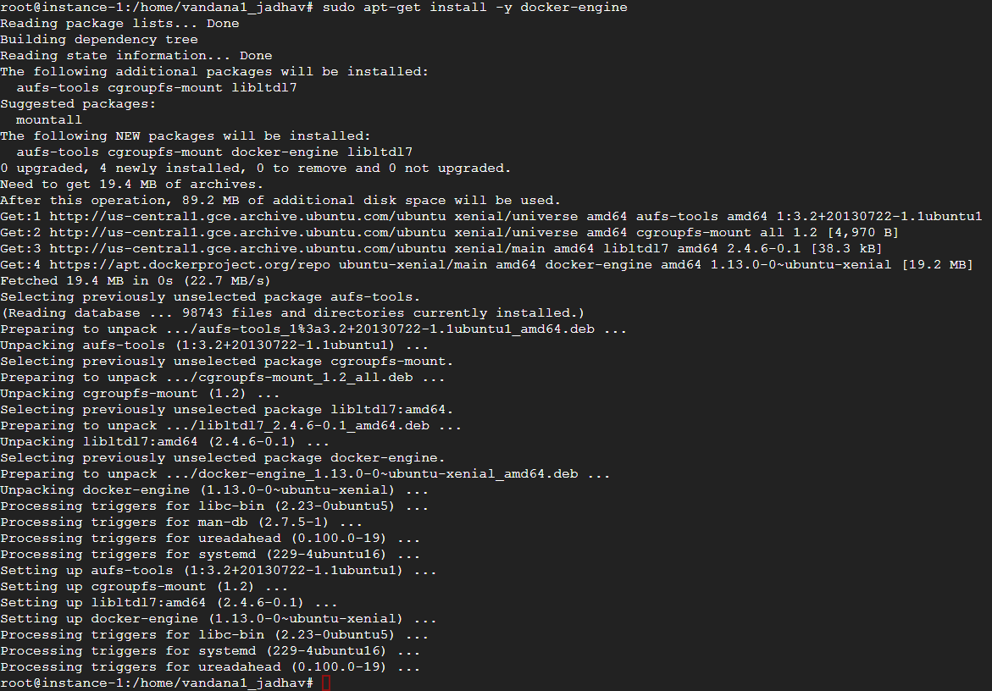

Check Docker installation

*$ sudo systemctl status docker*

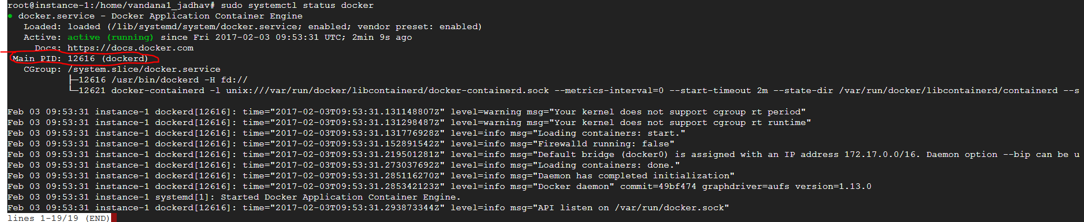

To avoid typing sudo whenever you run the docker command, add your user to the Docker group, log out of the Droplet and back in as the same user to enable this change.

$ sudo usermod -aG docker $(whoami)

Add your user to the Docker group

$ sudo usermod -aG docker $USER

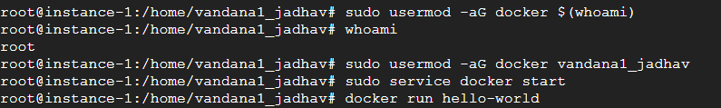

Step -4 Run Docker

$ sudo service docker start

Step -5 Test Docker is installed and running

$ docker run hello-world

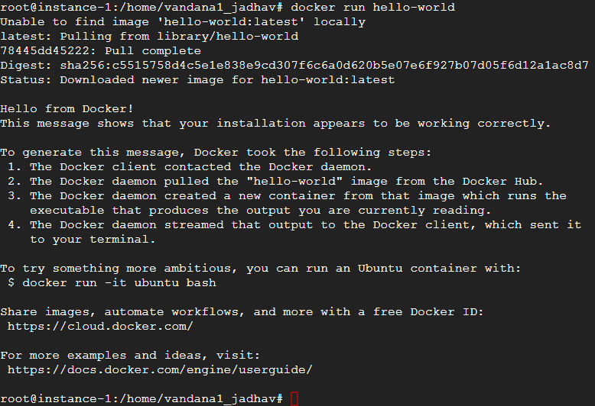

Install docker-compose:

$sudo –i

$ curl -L https://github.com/docker/compose/releases/download/1.8.1/docker-compose-`uname -s`-`uname -m` > /usr/local/bin/docker-compose

$ chmod +x /usr/local/bin/docker-compose

**Other References :**

**https://hyperledger-fabric.readthedocs.io/en/latest/asset_setup.html**

Operations guide -<http://hyperledger-fabric.readthedocs.io/en/v0.6/#operations-guide>

Setting up network-http://hyperledger-fabric.readthedocs.io/en/v0.6/Setup/Network-setup/

Docker machine on softlayer- <https://docs.docker.com/machine/drivers/soft-layer/>

Install Node js:

$ wget https://nodejs.org/dist/v4.4.4/node-v4.4.4-linux-x64.tar.xz

$ sudo apt-get install xz-utils

$ sudo tar -C /usr/local --strip-components 1 -xJf node-v4.4.4-linux.x64.tar.xz

Make soft link

$ sudo ln -s /usr/local/bin/node /usr/bin/node

$ sudo ln -s /usr/local/bin/npm /usr/bin/npm

$ node -v

v6.9.5

$ npm -v

3.10.10